**Leader Overview**

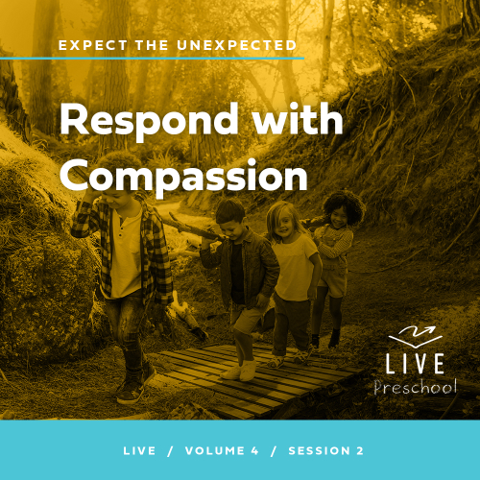

**Volume Overview**

**Expect the Unexpected**

*We all make plans—plans for where we’re going and what we want to do. But life is more often a story of unexpected interruptions. Our faith helps us to recognize God’s hand at work in unanticipated ways. By faith we learn to embrace life’s interruptions as the place God so often does miraculous things. We learn to respond with compassion and faith when things seem impossible.*

**Session Overview**

**Respond with Compassion**

*In this* **Live** *session, preschoolers will discover that God cares for the brokenhearted. He wants us to care for others who are sad. Kids will explore a Bible story where Jesus shows compassion for a woman who is overwhelmed with grief at the funeral for her only son. Kids will listen to God’s leading for the people in their lives they can show compassion to.*

**Bible Lesson**

Jesus Interrupts a Funeral Procession

[Luke 7:11–17](https://ref.ly/logosref/Bible.Lk7.11-17)

**Faith Fact**

I can show compassion.

**Faith Verse**

[Proverbs 3:5–6](https://ref.ly/logosref/Bible.Pr3.5-6) (NLT)

Trust in the Lord with all your heart; do not depend on your own understanding. Seek his will in all you do, and he will show you which path to take.

**Preparing for the Session**

**Leader Preparation Time: 20–25 Minutes**

|  |
| --- |
| ***You Will Need***  ***Preservice Activities***  *• Toys*  *•* ***Bible Story Warm-Up Page****, one per group*  *• Pretzel sticks*  *• Paper towels or napkins*  *Large Group*  *• Bible*  *• Worship songs (Song suggestions: “Your Love for Me” Lyric Video by North Point Kids; “Go Anywhere” Lyric Video by Rend Co. Kids; “Faithful” by Valley Creek Kids)*  *• For groups not using a phone or tablet only, add:*  *• Projector or TV*  *• Laptop*  *•* ***Faith Fact Sound*** *video (bell ringing)*  *•* ***Faith Fact Slide***  *•* ***Faith Verse Slide***  *•* ***Faith Verse Video***  *•* ***Bible Lesson Video A***  *•* ***Bible Lesson Video B***  ***Small Group***  *•* ***Small Group Group Connection Page****, one per group*  *• Card stock*  *•* ***Small Group Activity Page****, one per kid*  *• Crayons or markers*  *• Paper wads, twenty to thirty (optional: small balls, small balloons, etc.)*  *• Floor-safe tape*  *• Magnifying glass or smartphone camera*  *• Small items with a lot of detail: a coin, button, one LEGO, piece of jewelry, bag of fruit snacks with small print, someone’s fingerprint, etc.*  ***To access session content and videos from a computer, visit:*** [***BibleEngagementProject.com/downloads***](https://bibleengagementproject.com/downloads) |
| ***Getting Ready***  ***Preservice Activities***  *• Set out toys and snacks.*  *• Print the* ***Bible Story Warm-Up Page****.*  ***Large Group***  *• Download videos and slides if needed.*  *• Select worship song(s) and have them ready to play.*  ***Small Group***  *• Print the* ***Small Group Group Connection Page*** *on card stock.*  *• Print copies of the* ***Small Group Activity Page****, one per kid*  *• Place a strip of floor-safe tape down the center of the playing area to divide it in half for the game.*  ***First time leading* Live *for Preschool? Check out the*** [**Facilitator Guide**](https://0b769b0ed3569ef9d18b-f88d8272f61086866d50d048b43ef630.ssl.cf2.rackcdn.com/sites/biblengagementproject/Listen_Facilitator_Guide.pdf)**.** |

**Preservice Activities**

*See what’s needed at the beginning of the session.*

**Bible Story Warm-Up**

Has anyone ever needed help? *(Group response)* Whoa! That seems like everybody has needed help. I have pictures of some people who like to help others. Let’s see if we can figure out how they help us.

• *Hold up the* ***Bible Story Warm-Up Page*** *with pictures of helping professions.*

• *Allow kids to identify what they do and how they help people.*

Have any of these people helped you before? If so, how?

Who are some people you can help?

What are some ways that you could help others?

The Bible is filled with stories of Jesus helping other people. Today’s Bible story is about a time when Jesus stopped everything that was going on to help someone. The awesome thing is that Jesus still wants to help us today! I love learning more about Jesus, and I can’t wait to find out how He helped someone in today’s Bible story with you.

**Snack**

**Pretzel Sticks**

Today’s snack will require you to be a little creative. You’ll get some pretzel sticks, which are great for making things.

• *Hand out pretzel sticks and a paper towel to each kid.*

On your paper towel, I want you to use your pretzel sticks to make the shape of a house. This will help you remember that your house is a place where you could help somebody. How can you help someone at home? *(Allow responses.)*

Next, let’s take the pretzels and make a bigger building. We’ll pretend that it’s a school. Who is someone that you can help at school? *(Allow responses.)* Those are all great answers! You are super creative. I love that God made you like that. In our Bible story, we’ll learn about a really creative way that Jesus helped somebody. He wasn’t at home or at school, but we’ll find out more soon.

• *Allow kids to eat their snack.*

**Free Play**

*Any extra time can be spent playing with toys.*

**Transition**

*A few minutes before service begins have kids make their way to the large group area and sit in their designated areas.*

**Large Group**

**25 Minutes**

*See what’s needed at the beginning of the session.*

**Introduction**

Hi, friends! It’s such a great day when we get to be together! *(Hold up Bible.)* Today, we’ll explore a Bible story about a woman who was very sad. Can you show me your sad face? *(Group response)* When Jesus interrupted what was happening, the saddest day of her life suddenly became the happiest. Who has the happiest face they can show me? *(Group response)* It makes me so happy to see your happy faces. When we see people who feel sad, we can do something to show them that we care. That’s called showing them compassion.

**Faith Fact**

That’s our Faith Fact today. **I can show compassion**.

• *Show the* ***Faith Fact Slide.***

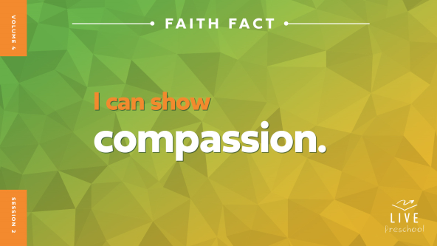

Let’s say our Faith Fact together and clap on each syllable of com-pass-ion. *(Demonstrate clapping on the syllable.)* Ready? **I can show compassion.** Okay, this time let’s stomp our feet three times when we say compassion. *(Demonstrate stomping.)* **I can show compassion.** That was so great, friends!

**Bible Time**

Now, it’s time for one of the best things we get to do when we come together, which is learn from the Bible. Does anyone have a guess about who we’ll check in with for our Bible story? *(Allow responses.)* Yes, Lizzy!

• *Play* ***Bible Lesson Video A****.*

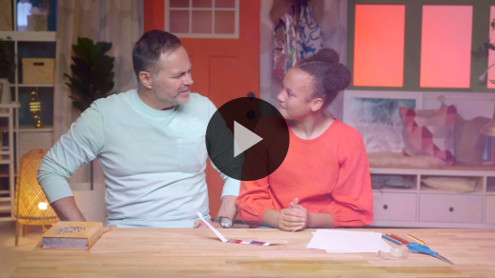

Hmm! That was a great clue for us to think about. In a few minutes, I’ll ask you what you think happens next in the story. First, wave your hands at me if you’re ready to worship the amazing God we serve. *(Group response)*

**Worship**

I love worshipping God with you. I love telling God how much we love Him. Let’s focus on how great our God is!

**Praise**

Who wants to thank Jesus for the joy He fills us with? Put your hands down by your toes and then move them all the way up to your head like you’re being filled with joy. *(Group response)*

Are you glad Jesus cares when we feel sad? Show me two thumbs up. *(Group response)*

Who wants to tell Jesus how much you love Him? Spread your arms out wide. *(Group response)*

**Sing**

Let’s worship Jesus now with our singing voices. Let’s warm up our high singing voice. Repeat what I do. *(Demonstrate high “la-la-la”)* Now, let’s warm up our low singing voices. *(Demonstrate low “la-la-la”)*

• *Lead the kids in singing one or two songs. See song suggestions at the beginning of the session.*

**Prayer**

Your worship was not only beautiful to my ears but also to Jesus. He loves to hear His children singing to Him. The Bible also tells us He wants us to talk to Him. That’s what we do when we pray. Let’s bow our heads and close our eyes while we pray.

|  |
| --- |
| *Dear Jesus, our worship songs remind us how wonderful You are. We thank You for Your great love for us, and we want to tell You how much we love You. Amen.* |

**Bible Time cont’d**

• *Start* ***Bible Lesson Video B*** *and pause on the image of the two choices.*

It’s almost time for Grandpa and Lizzy to come back! Let’s think about the answer to what happens next. Put on your thinking caps *(demonstrate).* What do you think happened? Do you think Jesus felt sad for the woman and wanted to do something? *(Point to the “heart” graphic on the hold screen.)* Or do you think He was too distracted by the large crowd to see her? *(Point to the “X” graphic on the hold screen.)*

If you think Jesus felt sad for the woman who lost her son, look at me with your saddest face and put your hands on your heart. If you think Jesus was distracted by the crowd and ignored her, look everywhere around the room except at me.

• *Pause while kids respond.*

Let’s find out if you’re right! Let’s check back in with Lizzy and Grandpa.

• *Play* ***Bible Lesson Video B.***

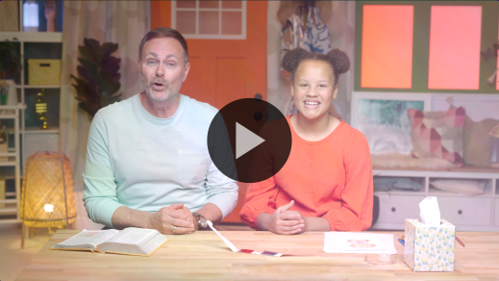

I love hearing how Jesus showed care and compassion for the woman who was sad. Sometimes I feel sad. Do you ever feel sad? *(Group response)* We all feel sad sometimes. Jesus cares for us in those moments just like He cares for us when we’re happy. Jesus shows us compassion.

**Response Time**

*Play a worship song quietly.*

Jesus also puts people in our life who can help us feel His love when we’re sad. They show compassion to us, too. He gives us the chance to show other people His love and compassion when they’re sad. Let’s respond to the truth we’ve heard today. I want you to close your eyes and ask God to help you think of someone you can show compassion to this week. Maybe it’s a brother, sister, parent, or grandparent. Maybe it’s a friend who sometimes seems sad. Let’s sit quietly and listen for Jesus to talk to us.

• *Pause to let kids think and listen for Jesus’ voice.*

If you’d like to share who you feel Jesus wants you to show compassion to, raise your hand.

• *Call on kids who raised their hands to share only the name or role (mom, little brother, etc.).*

Jesus loves it when we show people compassion. Let’s ask Him to help us.

• *Have the kids repeat phrases of the prayer after you.*

|  |
| --- |
| *Dear Jesus, I want to show compassion and Your love to someone this week. Please help me see who needs You. Help me show them compassion. I love You, Jesus. Amen.* |

**Faith Verse**

Did you know learning God’s Word is a great way to plant His truth in our life? Give me your biggest wave if you want God’s truth in your life. *(Group response)* Great! Let’s say our Faith Verse and do the actions together.

• *Optional: Teach only the first part of the verse in this session. Work on the rest in later sessions.*

[Proverbs 3:5–6](https://ref.ly/logosref/Bible.Pr3.5-6) (NLT)

Trust in the Lord with all your heart; do not depend on your own understanding. Seek his will in all you do, and he will show you which path to take.

• *Show the* ***Faith Verse Video****.*

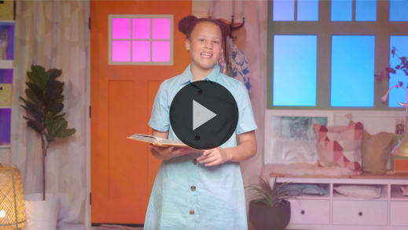

**Proverbs** *(hands at waist, spread apart, palms up and out)*

**3:** *(hands together like a clap)*

**5–6** *(hands opened to “book”)*

**Trust in the** **Lord** *(point up to heaven)*

**with all your heart;** *(place hands on heart)*

**do not depend on your own understanding**. *(bow head and place hands on head)*

**Seek his will** *(raise one arm and point to sky)*

**in all you do** *(spread out arms and spin around)*

**and he will show you** *(put hand over eyes like looking far away)*

**which path to take.** *(run in place)*

Wow, great job, friends! Keep practicing our Faith Verse at home, and we’ll say it again when we’re together!

**Closing**

We’ve had such a great day learning from the Bible together. Wait! Help me remember. Did we do everything? Did we sing? *(Group response)* Oh, right! We used our singing voices *(high voice)* La-la-la. Did we pray? *(Group response)* Of course, we prayed. Did we practice our Faith Verse? *(Group response)* Right. We had Lizzy’s help with that. Hmm. If I could just remember what is the last thing we need to do.

• *Play the* ***Faith Fact Sound*** *video (bell ringing).*

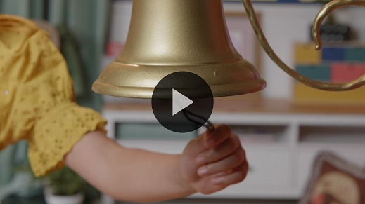

The Faith Fact! Does anyone remember what our Faith Fact was today? *(Allow responses.)* **I can show compassion.**

• *Show the* ***Faith Fact Slide.***



Great job! Let’s say it again while we clap our hands on *compassion*. *(Demonstrate clapping on the syllables.)* Ready**? I can show compassion.** Let’s stomp our feet now. **I can show compassion**.

**Dismissal to Small Groups**

Since you’ve been helping me remember what we’ve done, does anyone know where we go to next? *(Allow responses.)* Yes! We go to our small groups. Let’s do our fun circle activities now.

• *Dismiss the kids by groups.*

|  |
| --- |
| ***Leader Tip:*** *This can be done by assigning color teams or by age groups. Note that some young preschoolers may not know their age. Using a colored sticker, jersey, or wristband will help separate the kids and help identify their small groups.* |

**Small Group**

**25 Minutes**

*See supplies and prep instructions at beginning of session or in each activity below.*

|  |
| --- |
| ***Leader Tip:*** *Small groups can alternate to each circle, or all groups can do each activity at the same time. If you choose to alternate, you will need at least one leader per circle.* |

**Circle 1**

**Group Connection**

**Pass the Compassion**

|  |
| --- |
| ***You Will Need***  *•* ***Small Group Group Connection Page****, one per group*  *• Card stock*  ***Getting Ready***  *• Print the* ***Small Group Group Connection Page*** *on card stock.* |

Hi, friends! Let’s all sit together in a circle.

• *Allow kids to sit in a circle on the floor.*

In my hand I have a picture of a heart. Now, a heart represents a lot of things. It means love, kindness, caring, and it also can be a symbol of compassion. When we show compassion to others, we’re also showing them the love of Jesus. Today, we learned about a time when Jesus showed compassion to a very sad mother. He stopped what He was doing to help her. He made everything so much better for her. I want to remember to show compassion to people all around me. Do you want to do that? *(Group response)*

I have an idea! We should take this heart and pass it around the circle. As we’re passing it, let’s say our Faith Fact together. When the Faith Fact ends, we’ll stop passing the heart. Whoever has it will tell us one way they can show someone compassion and help them.

• *Pass the heart around the circle. Ensure that you play enough rounds to allow every kid to share about showing compassion.*

That was fantastic! You came up with a lot of ways to show others that you care.

**Circle 2**

**Activity Page Time**

**Compassion Count**

|  |
| --- |
| ***You Will Need***  *•* ***Small Group Activity Page****, one per kid*  *• Crayons or markers*  ***Getting Ready***  *• Print copies of the* ***Small Group Activity Page****, one per kid.* |

Today, we’ve learned how we can have compassion like Jesus did. To show compassion like Jesus, we help others who are in need. When we take what we learn in the Bible and use it in our life, we show God that what He says matters to us.

• *Hand out a copy of the* ***Small Group Activity Page*** *and crayons to each kid.*

We can show people compassion when they are sad like Jesus did. Can you point to a face of someone who is sad? *(Group response)* Which face shows how the woman probably looked after Jesus showed compassion to her? Point to it. *(Group response)* I think she was very happy.

There are other feelings we can see when people need compassion. What other feelings can you see on this page? *(Allow responses.)* We can see a lot of faces of people who need compassion. Count how many you see of each feeling and circle the right number in the boxes below.

• *Give kids time to complete the page. Assist them as needed.*

• *During the activity, interrupt and practice the Faith Fact:* **I can show compassion.**

• *Play the* ***Faith Fact Sound*** *video. Review the Faith Fact even if you can’t play the sound.*



**Circle 3**

**Feet-to-Floor Game Time**

**Clean Sweep**

|  |
| --- |
| ***You Will Need***  *• Paper wads, twenty to thirty (optional: small balls, small balloons, etc.)*  *• Floor-safe tape*  ***Getting Ready***  *• Place a strip of floor-safe tape down the center of the playing area to divide it in half for the game.* |

Today, we’ve learned about *(pause as if you can’t remember).* Who can help me remember the Faith Fact? *(Group response)* Oh, wow! That’s great how many of you already know the Faith Fact. Let’s all say it together. **I can show compassion.** Perfect.

When we show compassion, we do something to help someone who is sad or hurt or angry. Anytime we show compassion, we’re helping someone. It’s like we want to take away their sadness and make them happy.

• *Pour the paper wads all over the playing space, half on each side of the taped line.*

We’ll make two teams. When I say, “Go,” you’ll work together to toss as many of these items across the playing area to the other side as you can. At the end of the time, whoever has fewer items on their side is the winner. Who’s ready to play? *(Group response)*

• *Divide the group into two teams.*

• *Play this game for as many rounds as time permits. In between each round have the kids say the Faith Fact.*

Wow! Everyone did amazing! Let’s see how fast you can help pick up everything. Ready? Go!

• *Encourage kids to pick everything up as quickly as possible*

Let’s all say our Faith Fact together one more time as loud as we can. **I can show compassion.**

**Circle 4**

**Hands-On Learning**

**Take a Closer Look**

|  |
| --- |
| ***You Will Need***  *• Magnifying glass or smartphone camera*  *• Small items with a lot of detail: a coin, button, one LEGO, piece of jewelry, bag of fruit snacks with small print, someone’s fingerprint, etc.*  *No prep needed for this activity.* |

Our Faith Verse says that the more time we spend with God, the easier it is to know what He wants us to do. Let’s say our Faith Verse and do the actions together.

**Proverbs** *(hands at waist, spread apart, palms up and out)*

**3:** *(hands together like a clap)*

**5–6** *(hands opened to “book”)*

**Trust in the Lord** *(point up to heaven)*

**with all your heart;** *(place hands on heart)*

**do not depend on your own understanding.** *(bow head and place hands on head)*

**Seek his will** *(raise one arm and point to sky)*

**in all you do** *(spread out arms and spin around)*

**and he will show you** *(put hand over eyes like looking far away)*

**which path to take.** *(run in place)*

• *Optional: Teach only the first part of the verse in this session. Work on the rest in later sessions.*

Great job! When you seek something, that means you look for it. You study it to see the details in it. We can do that with some things in everyday life. To get a really close look, you have to use something that helps you see things bigger and better. Does anybody know what could help you see things better? *(Allow responses.)* Those are good things to help us get a better look at something. And I brought something with me. *(Hold up a magnifying glass.)* Does anybody know what it is? *(Allow responses.)*

This is a magnifying glass. When you look through it, the thing you’re looking at seems bigger. It allows you to see details that you might not have seen with just your eyes. Would anyone like to take a turn and look through this? *(Group response)*

• *Allow kids to look at the items.*

Just like you could see things more clearly when you look through the magnifying glass, the more time you spend studying God’s Word and getting to know Him, the more clearly you will know God’s plans for you. A great way to do that is to memorize it. That’s why learning our Faith Verse is so important. Let’s take a minute right now and practice our verse together one more time.

• *Lead the kids through Faith Verse with actions.*

That was amazing! Be on the lookout for the things that God wants to show you, especially when you see people who need compassion.

**Dismissal**

• *Play the* ***Faith Fact Sound*** *video (bell ringing).*



• *Show the* ***Faith Fact Slide.***

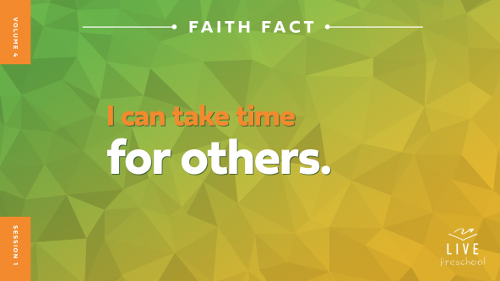

Oh, that sound means it’s time to say our Faith Fact together. **I can show compassion**. I’ve had so much fun learning with you today. I think my favorite thing I learned today was our Faith Fact. **I can show compassion**. What was your favorite thing about today? *(Allow responses.)* Awesome! Bye, friends, see you next time.

• *Send home the* ***Small Group******Activity Page*** *with each kid.*

• *Remind parents that there are* ***Family Devotions*** *available on the app to do with their kid.*

• *Tell everyone the date and time for the next session.*